**Welcome to the object-tracking!**

**What is object tracking?**

Object tracking is a process of locating a moving object throughout the video and giving it a unique Id.

**Multiple Object Tracking (mot)**

MOT is a compute hungry task which involves tracking (association of object between frames) followed by detection.

**Real time IOU tracker:**

We have implemented the real time tracker based on IOU principal

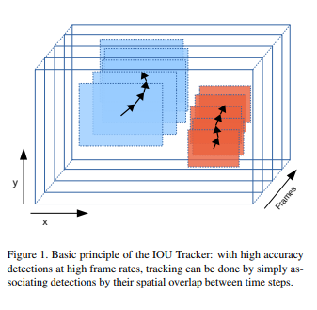

**How to run:**

Download weights file and keep it in object-tracking master

<https://drive.google.com/file/d/1a-64b6y6xsQr5puUsHX_wxI1orQDercM/view>

Install the packages using environment file mentioned using conda.

1. Open ssd512inference notebook from object tracking master
2. Put the video file path in read input cell
3. Check the output vide